**Project Design Phase-II**

**Data Flow Diagram & User Stories**

|  |  |
| --- | --- |
| Date | Date: 26 June 2025 |
| Team ID | Team ID: LTVIP2025TMID44725 |
| Project Name | Poultry Disease Detection Using Transfer Learning |
| Maximum Marks | 4 Marks |

**Data Flow Diagrams:**

A Data Flow Diagram (DFD) is a traditional visual representation of the information flows within a system. A neat and clear DFD can depict the right amount of the system requirement graphically. It shows how data enters and leaves the system, what changes the information, and where data is stored.

Example: DFD Level 0 (Industry Standard)

(Placeholder for Level 0 DFD Image)

Example: (Simplified)

(Placeholder for Simplified DFD Image)

Burndown Chart Example:

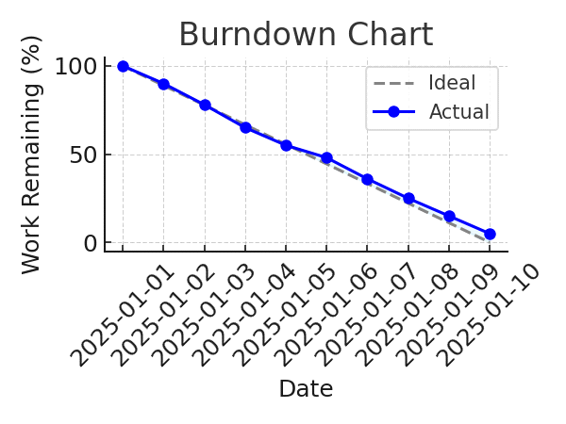

**User Stories**

Use the below template to list all the user stories for the product.

|  |  |  |  |  |  |  |
| --- | --- | --- | --- | --- | --- | --- |
| User Type | Functional Requirement (Epic) | User Story Number | User Story / Task | Acceptance criteria | Priority | Release |
| Customer (Mobile user) | Registration | USN-1 | As a user, I can register for the application by entering my email, password, and confirming my password. | I can access my account / dashboard | High | Sprint-1 |